Brandeis University Robotics Club

Engineering Notebook for Zumo Automation Project

Contributors: Jacob Smith, Matthew Millendorf

Advisor: Tim Hebert

Abstract: This project’s main goals are to create a user-friendly platform to program the ZUMO32U4 robots in, and to allow for automated testing of sumo-competition strategies





2018.8.14 Jacob Smith 8:38 PM: I have been researching how to build a proper mini-sumo ring, here are some helpful links

https://maker.tufts.edu/projects/sumobots

2018.8.15 Jacob Smith 1:33 PM I also have some links for sensors that Deis Robotics may want

**MyoWare Muscle Sensor:** [**https://www.pololu.com/product/2732**](https://www.pololu.com/product/2732)

**Electrodes for MyoWare Muscle Sensors (6-Pack)** [**https://www.pololu.com/product/2733**](https://www.pololu.com/product/2733)

**Pololu IR Beacon Transceiver Pair** [**https://www.pololu.com/product/702**](https://www.pololu.com/product/702)

**Parallax ColorPAL** [**https://www.pololu.com/product/1608**](https://www.pololu.com/product/1608)

So the options for construction are:

Mini Sumo Ring Options:

|  |  |  |  |
| --- | --- | --- | --- |
| Type of Ring | Link | Pros | Cons |
| Ring Poster | <https://engineerdog-webstore.fwscart.com/SimpleSumo_Competition_Poster/p4970409_17776128.aspx> | Ready to order ring | Colors aren’t official regulations |
| Pre Cut Wooden Ring | <https://www.instructables.com/id/How-to-Make-a-Mini-Sumo-Ring/> Option 2  List of supplies:  <https://www.amazon.com/hz/wishlist/ls/28AAHJ3MS18PQ> | Less work than cutting ring ourselves | Ring can’t be recessed |
| Self Cut Wooden Ring | <http://www.robotroom.com/SumoCircleMini.html> | Would let ring be either raised or recessed | Takes a lot of physical work |

Rules of Mini Sumo: <http://robogames.net/rules/all-sumo.php>

The other consideration as we think about building the mini sumo ring is how the robot should detect that it has gone over the edge, especially if that involved an extra color of paint as an out of bounds marker for the infrared sensors

September 20 2018 4:10 PM Jacob Smith: I am preparing a demonstration for the robotics club meeting, using this tape I got from Tim: <https://www.amazon.com/dp/B01NANPNZC?ref=yo_pop_ma_swf>

Line Sensor Printing Values

Black Tape: 1160,900,1016, avg=1025

White Table: 160, 100, 100 avg =120

September 27 2018 5:18 PM Jacob Smith: TEACHING: So Last week the students used my Drive class to get the robot to push another robot out of the ring. The idea is to introduce students in to how to actually get the robot to drive.



POSTERS: Also, Tim bought two posters with the official color layout, which the poster on the previous page doesn’t have. <https://www.parallax.com/product/27404>

<http://www.sumorobotleague.com/purchasekits/competition-ring>

10.4.2018 Jacob Smith 3:55 PM: Last week, I showed the members how loops repeat code over and over again. This is the difference between the loop and setup methods in Arduino, setup doesn’t repeat and loop does. I asked them to use this idea to write a program for the robot to drive in a square.

They came up with the left solution, which shows that driving in a square is really a repeated process.

Then, I showed them how to use the isOnLine function to determine if it is on the edge of the ring, and how they can write a program that does one thing when the robot is on the edge, and another when the robot is inside the ring.



The program they filled in to the loop was the correct idea of how to make sure the robot stays in the ring, but in practice the line detection didn’t work very well.

October 11 2018, Last week, the students worked on using a provided proximity sensor program to think about how it could help the robot in the ring. This fits in to the theme of giving the robot more information on the world around it. Here is the example program, which is a lot more effective than the one I tried on page 15. <https://www.youtube.com/watch?v=ddPo6HQvxzQ>.Today, I am going to build the example program into a class so the students can use it in a strategy.

I wrote proximity sensor class, and it has a nice lcd printing trick. Previously, I was clearing the LCD every time and having a delay. But the example code just resets the cursor instead of clearing, so no delay is necessary.

10.18.2018 Jacob Smith 5:35 PM: This is the proximity class.

­­

Today, I made sure that GitHub desktop and the zumo automation GitHub are installed on one of the automation lab computers. Today, I will teach intro to GitHub, have the students make accounts, and then have them test out the proximity example file. Finally, the students could combine the proximity program with the line sensor program on page 62.

<https://www.thingiverse.com/thing:2662828>

11/1/2018 4:56 PM Jacob Smith. Last Week, I wrote a tutorial to install GitHub desktop, Arduino, and our libraries onto a computer, which is here <https://brandeismakerlab.dozuki.com/Guide/Getting+Started+with+Zumo+Automation+Project/27?lang=en>

Currently, the project setup in GitHub leads to an error message that the instructional code can’t be used as a library. Ideally, I would make a separate GitHub project to hold those programs, like zumo automation front end and back end.

11.8.2018 Jacob Smith 5:02 PM: GITHUB: New members of the robotics club can’t push changes with GitHub desktop, I submitted a help request to GitHub.

LINE SENSOR: Last week, the students collected line sensor readings for our two Zumo mats, and started thinking about how to write a boundary detection program as a teaching exercise.

The data they collected suggested that the grayscale mat has much better brightness contrast, so that will be what we will use.

LIBRARIES:

<https://arduino.stackexchange.com/questions/14189/how-to-develop-or-edit-an-arduino-library>

<https://forum.arduino.cc/index.php?topic=423472.0>

<https://github.com/arduino/Arduino/wiki/Library-Manager-FAQ>

To edit how to edit Arduino libraries in the Arduino integrated development environment, you need to create a sketch with the name of the folder, and move the library to your sketches folder.

This is the contents of the drive class:



November 15 2018 Jacob Smith: GITHUB: the error about permissions was because the makerlab organization has individual permissions instead of blanket permissions

November 29 2018 Jacob Smith: PLANNING: Tim and I talked about the planning of the project, and I looked up some of the background of machine learning. So, there are three types of machine learning that I know about: Decision Trees, Neural Networks, and Evolution. Decision trees take training data and generate essentially a set of if else statements to classify the data. A neural network simulates a bunch of neurons, which fire based on their state, and an evolution scheme has players play a game, the winner’s strategy survives. We will use an evolutionary scheme because it doesn’t require training data, is simpler, and models a real biological process. Here’s what we need to accomplish this:

1. An input to the robot of its acceleration
   1. We have that, but need to calibrate sensor
2. An input to robot of the line sensor
   1. Would be in ring or on edge
3. Distance Sensors input to robot
   1. Will implement scheme in line 271 of <https://github.com/pololu/zumo-32u4-arduino-library/blob/master/examples/SumoProximitySensors/SumoProximitySensors.ino>
4. A way for robot to reset its position
5. A way for robot to know who lost
   1. Bluetooth
   2. Or infrared broadcasting
6. A function that inputs all the sensor values mentioned above and outputs a speed for left motor and speed for right motor
   1. This is the machine learning part, because the weighting of the algorithm will determine what the robot does

Finally, this fits into the archum asylum trip because we could write a human motion function instead of having the robot do it. So the first The first milestone of the machine learning project will be simply getting the robot to stay in the ring.

So to start, I will set up A D and E which are background programming, and in club we’ll do B, C which is more accessible.

9:25 PM: I gave out B and C to robotics club members, also earlier Tim and I worked out the GitHub error, from 11/15. It happened because people were trying to directly commit to the main project, which only the owner and project creator can do in an organization. The solution is for everyone including me to make our own fork of the project, and then create a pull request for Tim or me to merge into the main project, I updated <https://brandeismakerlab.dozuki.com/Guide/Getting+Started+with+Zumo+Automation+Project/27?lang=en> to fit this.

1:36 AM: ACCELERATION: I rewrote the Accel class to stabilize the accelerations it outputs. Now, if the accelerations are close to the resting state for that axis ie. If X and Y axis are close to 0 or Z axis is close to 1800, it will fix the print to that resting state.

In addition, accelerations are only updated when they are 20 cm/s^2 different from previous reading, which should help to handle the random variation of the sensor. Following is the Accel.h header file showing new private methods.



These are the relevant portions of the accel .cpp file, the getRawAcceleration is the same as the getX, getY, and getZ functions from April 23 3018, so really I’ve encapsulated the acceleration readout further, because that method is private, and the public getX ,getY , and getZ methods include filtering.

The offsets works by stopping the robot for a few seconds, and taking the average acceleration for every axis. This offset is then subtracted from the raw acceleration reading, so the robot can have a resting state.

UpdateAccels makes sure acceleration stays at resting state if it is close and only updates when acceleration is very different.

This is the output of the robot printing its acceleration values, notice how much stabler and more intuitive the readouts are compared to April 23 2018.



Finally, to practice with the new acceleration class, I wrote this loop which allows the robot to know whether it is flipped over, because the z axis will have a negative acceleration.

Notes: I haven’t shown that the acceleration data is useful for the robot yet, and also using the accel class is complicated with both types of robots, because the compiler doesn’t know which one’s class to use.

FUTURE PLANNING: I will work on part F from today, and then possibly a way for robot to reset once it’s lost a match.

Jacob Smith 12.5.2018: I wrote the Encoder Driver class, which uses the Encoders on the robot to maintain a constant velocity of the robot. The alternative do using this class is to set a speed from 0 to 400, which is arbitrary and specific to the robot. By setting velocity, we use a useful measure and hopefully will minimize difference between robots, meaning that two robots could have to ramp up to different powers, but will achieve the same speed.

The setSpeeds example file:



The EncoderDriver header file:



The Encoder Driver Body File

TO DO: Get Tim to look at motors, ask if we can replace zumo32u4 motors? Explore Eclipse as an Arduino program editor

1/17/2018: Jacob Smith: I worked on making the Arduino IDE easier to use, and I used these sources

<https://forum.arduino.cc/index.php?topic=466166.0> post 8

<https://github.com/arduino/Arduino/wiki/Arduino-IDE-1.5:-Library-specification>

To allow all files in a library to be edited in the Arduino ide, so nothing is read only and we can edit classes.

This is what the folder for a class looks like now, it has .development and library.properties, and a .ino file with same name as it

library.properties file:



.development file (contents don’t matter)



libaryName.ino file (contents don’t matter)

also, see the class files .cpp and .h are visible



FUTURE SOFTWARE: I also tried to use the Eclipse extension Sloeber, but I haven’t really worked with it. Eventually want to publish code this way (see bottom)

NOTE: While programming ZUMOSHIELD, Treat driveShield as Arduino genuine uno, and don’t put the robot on the table

LINEPRINTERREGION: In addition, I wrote a lineShield example file that prompts the user to place the robot on different regions of the sumo ring, displays sensor readings, and calculates thresholds using the average sensor value.

I used it on the gray zumo mat with no one else, and that used to be a two person task. The output is below.

The exciting thing about this program is that it should work for any number and name of regions, because it relies on an array of region names, which should be in increasing order

https://github.com/arduino/Arduino/wiki/Library-Manager-FAQ

Output of Line Printer Example File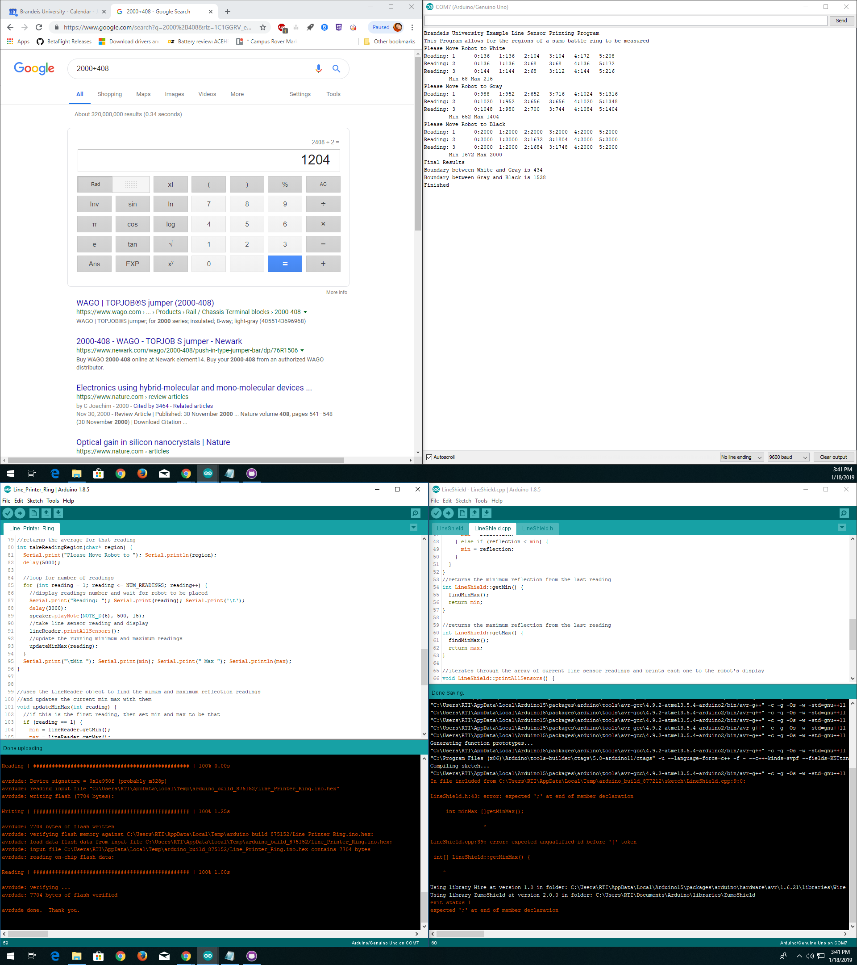

Brandeis University Example Line Sensor Printing Program

This Program allows for the regions of a sumo battle ring to be measured

Please Move Robot to Black

Reading: 1 0:2000 1:2000 2:2000 3:2000 4:2000 5:2000

Reading: 2 0:2000 1:2000 2:2000 3:2000 4:2000 5:2000

Reading: 3 0:2000 1:2000 2:2000 3:2000 4:2000 5:2000

average for this region:2000.00

Please Move Robot to Gray

Reading: 1 0:1052 1:948 2:652 3:716 4:1016 5:1204

Reading: 2 0:1156 1:1020 2:672 3:704 4:980 5:1156

Reading: 3 0:988 1:920 2:652 3:688 4:952 5:1092

average for this region:920.33

Please Move Robot to White

Reading: 1 0:136 1:136 2:68 3:100 4:136 5:172

Reading: 2 0:136 1:136 2:72 3:104 4:136 5:172

Reading: 3 0:136 1:136 2:68 3:100 4:136 5:172

average for this region:124.67

Final Results

Boundary between Black and Gray is 1460.17

Boundary between Gray and White is 522.50

Finished